3. ReactJS-HOL

Solution:

1. **Created a React project** named “**scorecalculatorapp**” type the following command in terminal of Visual studio:

**( npx create-react-app scorecalculator ).**

1. 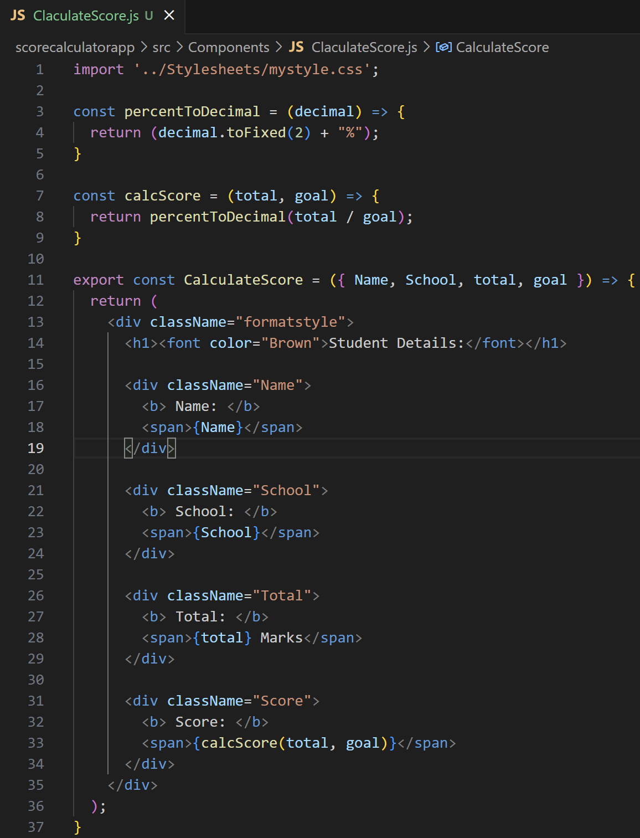 **Created a new folder** under Src folder with the name “**Components**”. **Added a new file** named “**CalculateScore.js**”
2. **Created a Folder** named **Stylesheets** and **added a file** named “**mystyle.css**” in order to add some styles to the components:
3. **Edited the App.js** to invoke the CalculateScore functional component as follows:

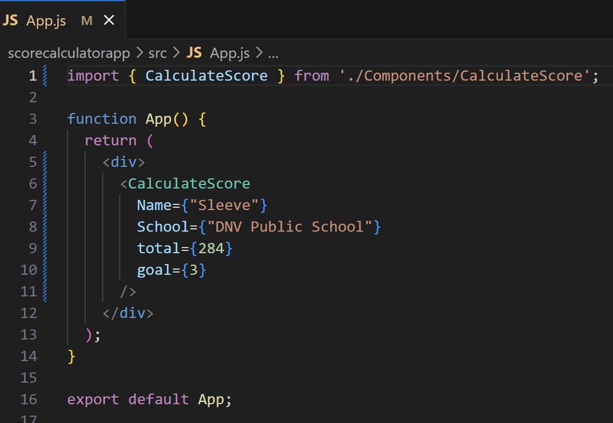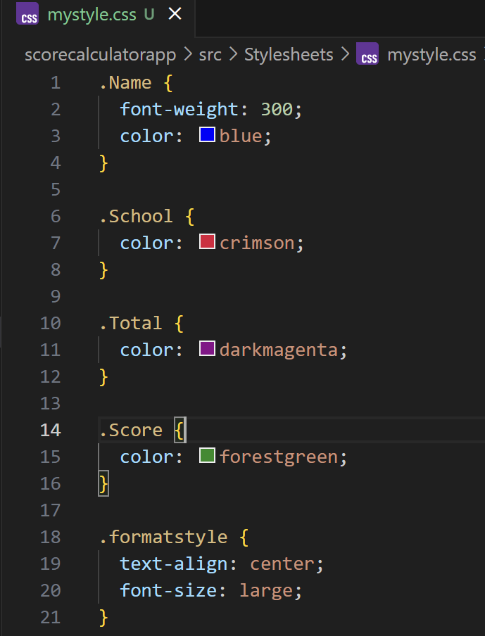

1. In command Prompt, navigate into scorecalculatorapp and execute the code by typing the following command:   
    scorecalculatorapp> npm start
2. 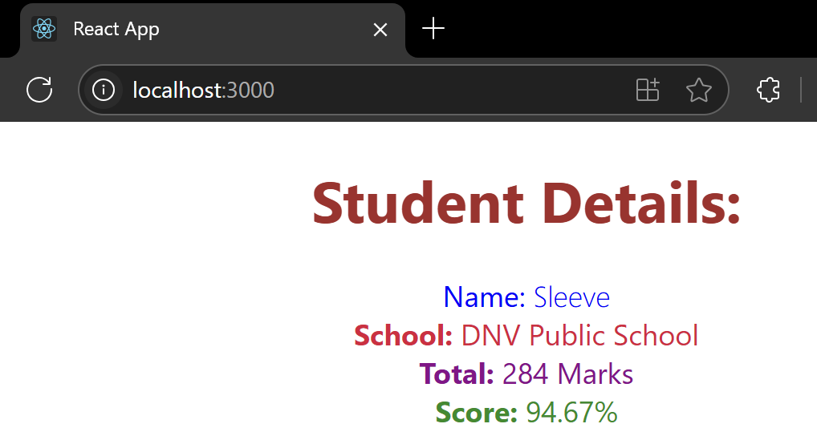**Open browser** and type “**localhost:3000**” in the address bar:

****************************************************************************************